The UDP Band Map
Aki Yoshida JA1NLX

1. 0 GENERAL

Logger32 has a function to receive and display decoded callsigns with some additional informations on the UDP BandMap and send reply message to JTDX or WSJT-X. JTDX or WSJT-X works as if callsign is double-clicked on it's window when it receive reply message.This data is distributed via UDP (User Datagram Protocol) appromixmately every 15 seconds (FT8 Mode) or 60 seconds (JT65, JT9 Mode etc) by WSJT-X/JTDX program. The reply message is sent via UDP.
When QSO is logged in WSJT-X/JTDX then Logger32 log this QSO via UDP.

Note 1: When QSO is logged in JTDX then Logger32 will log this QSO via UDP.
Note 2 1: The UDP BandMap and JTAlert program can not run work at same time.
Note 3 2: If using JTDX, use either the TCP Server method OR this UDP server method – NOT both. Use TCP or UDP for logging.

2. WSJT-X/JTDX SETTINGS

2.1 Settings in WSJT-X program

Look for UDP Server group. You should leave the default value like this.

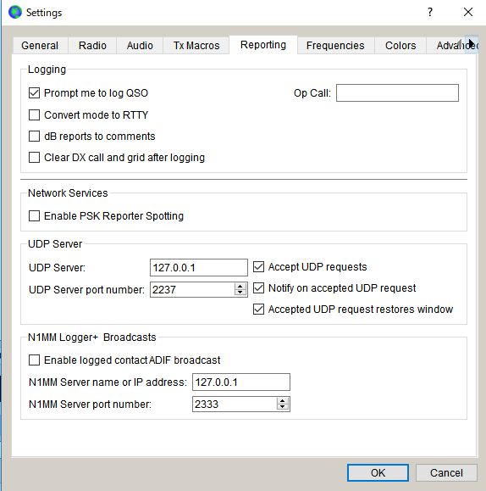

new UBM_1

2.2 Settings in JTDX program

Look for UDP Server group. You should leave the default value like this.

If you do not use External logbook connection then uncheck "Enable data transfer to external log"

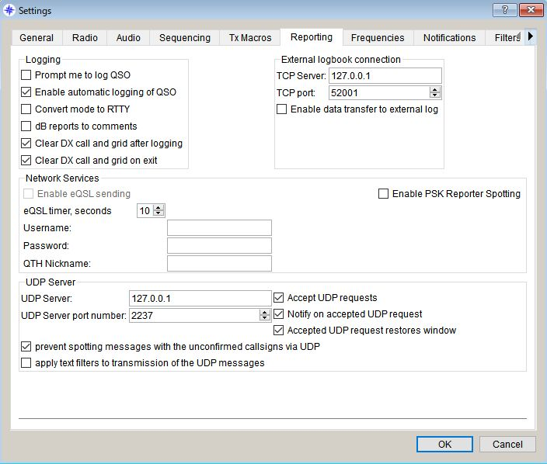

new UBM_2

3.0. LOGGER32 SETTINGS
The callsign highlight colors and DXCC award tracking informations displayed in UDP BandMap depend on the settings in "DX Spot highlight color" and "Setup phone/digital modes"

Settings for me to operate FT8, JT9 and JT65 below.

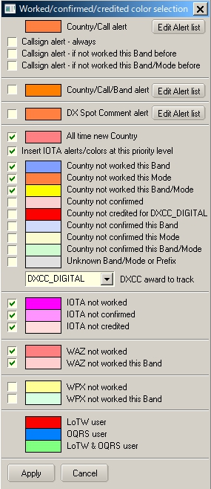

UBM_3

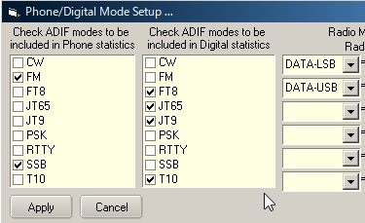

UBM_4

With this settings Worked/confirmed Window looks like below.

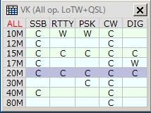

UBM_4A

4. OPERATION (1)

  - Run WSJT-X or JTDX. Do not run JTAlert at same time.
  - Run Logger32
  - Right click on "UDP" in the lower status bar. Click "Open UDP BandMap"

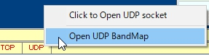

UBM_5

When WSJT-X or JTDX decode callsigns these callsigns are displayed in the UDP BandMap.

WSJT-X or JTDX, Band and Mode are displayed in title bar. Band and Mode are derived from WSJT-X or JTDX.

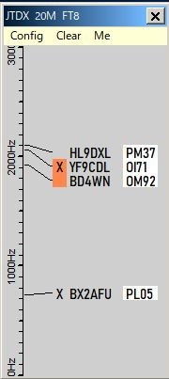

new UBM_6

  - Click "X" to close UDP BandMap.

5.0 MENU

5.1 Config

There are a lots of options. You may choose whatever you prefer now.

If you want to see highlight colors and tooltips informations based on every mode then un-check "Highlight callsigns as "DIG" mode" This option works for displaying "QSOd B4" mark as well.

If you want to use direct logging then check "Allow QSO automatic logging" If you want to see Gridsquare then check "Show Gridsquares"

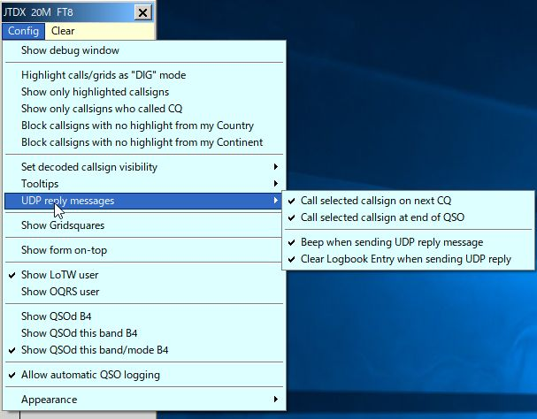

new UBM_7

Sub menu for "Set decoded callsign visibility"

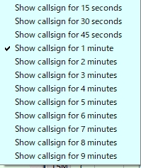

UBM_8

Sub menu for "Tooltips"

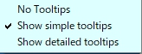

UBM_9

Sub menu for "Appearance"

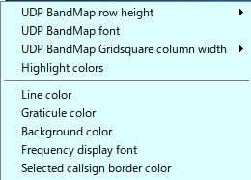

new UBM_10

UDP BandMap Gridsquare column width

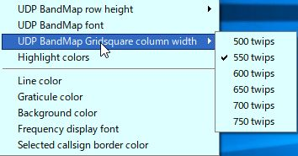

new UBM_10A

Click "Highlight colors" to configure Gridsquare highlight colors and UDP BandMap text color. If you prefer to see bold text for callsign who have called CQ then check "Show bold text who have called CQ"
.

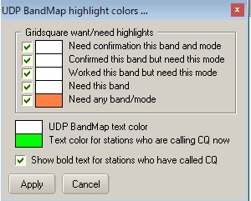

UBM-11

Sample below. The stations who are calling CQ now are displayed in Green text, the stations who have called CQ are displayed in white/bold text and the stations who are working other stations are displayed in white text.

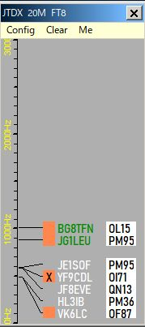

new UBM_11A

5.2. Clear

This clears UDP BandMap.

5.3. Me

This opens Calling Me UDP BandMap. See details in paragraph Operation(4).

6. OPERATION (2)

If you move mouse over callsihgn then tooltips appears.

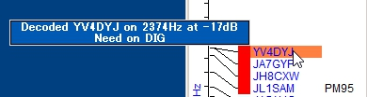

UBM_12

If you left-click any callsign then this callsign is transferred in Logbook Entry Window.

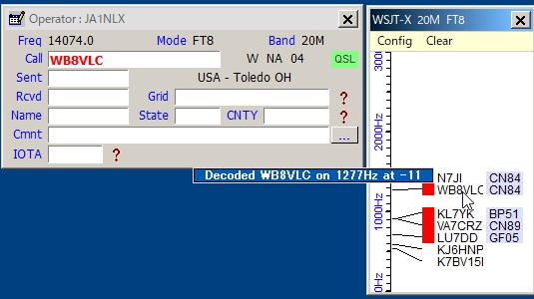

UBM_13

If you right-click any callsign then history of this callsign is displayed. (max 15 messages)

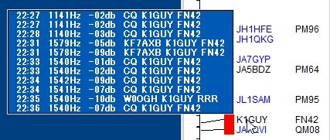

UBM_14

If you confugure various options properly then you see LoTW/OQRS user, QSO B4, highlighted callsign and Gridsquare.

When QSO is logged in WSJT-X/JTDX then Logger32 log this QSO via UDP if "Allow QSO automatic logging" is checked.

7. OPERATION (3)

Logger32 can send reply message to JTDX or WSJT-X When it receives reply message then it will transmit message corresponding to the reply message.

For JTDX following options should be checked and “AutoTX” should be turned ON.

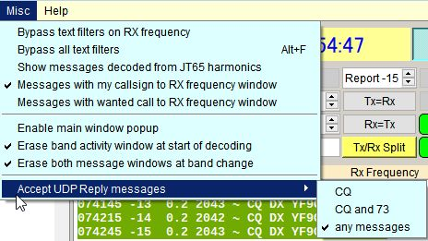

UBM_14A

For WSJT-X Auto Seq should be checked and “Call 1st” should be unchecked.

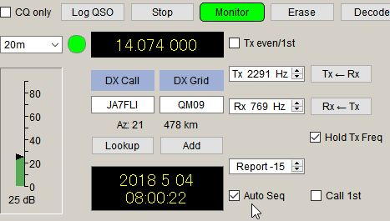

UBM_14B

Following options should be checked in UDP BandMap Config menu. Uncheck “Call selected callsign at end of QSO” if WSJT-X is used.

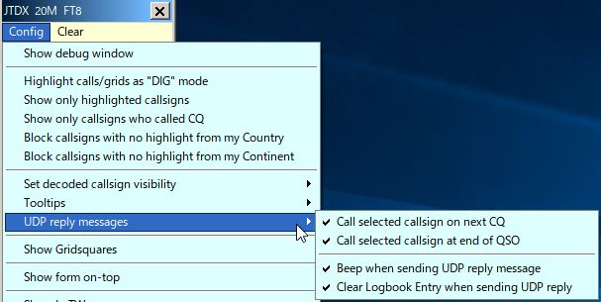

UBM_14C

Click on any callsign you want to call. The callsin is surrounded by box and transferred in Logbook Entry Window. Box border color can be configured in “Config”, “Appearance”, “Selected callsign border color”.

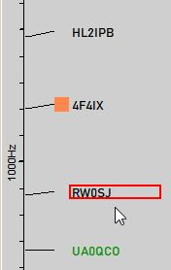

UBM_14D

When
(a) he calls CQ on next time slot, reply message is sent to JTDX or WSJT-X and it will transmit message calling him.
(b) he sends message with 73 or RR73 or RRR, reply message is sent to JTDX and it will transmit message calling him.

Logbook entry window is cleared.

8. Operation(4)

Click “Me” in the Menu to show Calling Me BandMap. Only callsigns calling me are displayed in this window.

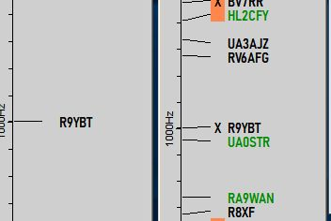

UBM_14E

For JTDX:
It may be a little complicated because JTDX has various options for Auto Seq. It is better to use following setup to use this functionality.

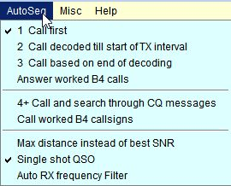

UBM_14F

When you call CQ and receive multiple reply, these callsign are displayed in Calling Me BandMap. JTDX will transmit message automatically for the first decorded callsign. When you finish this QSO, click another callsign. JTDX will transmit message for this callsign.

For WSJT-X:
Set options like UBM_14B. When you call CQ and receive reply, callsigns are displayed in Calling Me BandMap. Click any callsign you want to answer. WSJT-X transmit message for this callsign.

If you move mouse over callsign then tooltips appears.

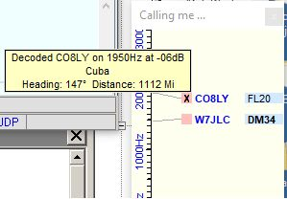

UBM_14G

709. TIPS

If you have "Show only callsigns calling CQ" and "Show only highlighted callsigns" checked then the only station that are highlighted and calling CQ will show.
The BLOCK COUNTRY and BLOCK CONTINENT options look for a Country/Continent match with the Logger32 Current Operator. If you have the Logger32 operator set to "At the Beach" or "Club Station" or something other than the callsign of where you are operation, the results will be unpredictable.

Try to change settings of "DX Spot highlight colors" in DX Spot Window and settings of "Setup phone/digital modes" in Tools menu. It affects the way to display highlight colors and tooltips in UDP BandMap.

Debug window is very useful to check problem. Click "Show debug window" in Config menu to show debug window. Reply message is displayed in Red text.

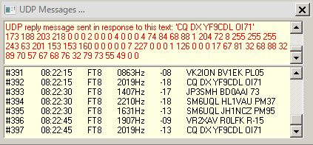

new UBM_15

